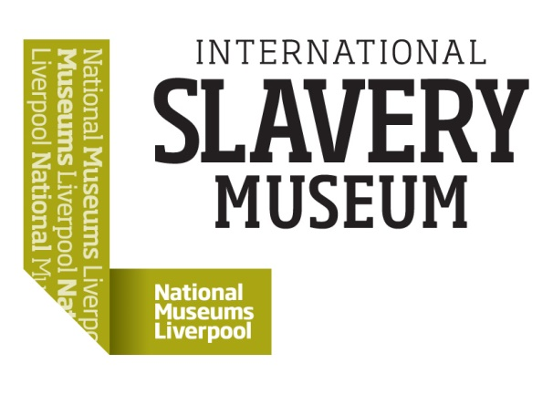

International Slavery Museum - Ambassadors Programme, ages 17-22

Are you passionate about arts, history and culture? Are you interested in championing human rights education? Would you like to gain experience within the cultural sector working with artists, curators and museum educators to find new ways of engaging the public with our museum collections?

Join International Slavery Museum as a Young Ambassador to gain a behind the scenes insight into roles within our museum, challenge legacies of slavery such as racism and inequality, get involved in artist-led workshops and even programme and host museum events and activities. An unmissable opportunity for anyone interested in history, activism, arts and culture.

The programme with run from November 2018 to August 2019 and the Ambassadors’ group will meet once a month. All sessions run 1-4pm.

Applications are open to anyone aged 17-22. Please send your completed application form to [stef.bradley@liverpoolmuseums.org.uk](mailto:stef.bradley@liverpoolmuseums.org.uk) by 5pm on Thursday 8th November 2018.

Programme dates:

17 November

1 December

19 January

9 February

16 March

13 April

18 May

15 June

13 July

23 August



**Application Form**

**International Slavery Museum- Ambassadors’ Programme**

Please note that programme dates are:

*17 November, 1 December, 19 January, 9 February, 16 March, 13 April, 18 May, 15 June, 13 July, 23 August*

**First Name:**

**Surname:**

**Date of Birth:**

**Age:**

**Email:**

**Home Address:**

**Do you have any medical, access or educational needs that you would like the course leaders to be aware of?**

**Emergency Contact Name:**

**Emergency Contact Tel:**

**For participants under 18 years, parental consent is required**

**I give permission for _______________________ to participate in the Ambassadors Programme at International Slavery Museum.**

**Name of Parent/Guardian: ___________________**

**Signed: _______________________**

**Date: _________________________**

**Please explain why you are interested in participating in International Slavery Museum’s Ambassadors Programme and how you feel that you will benefit from this experience. Outline any skills or experience you have that you feel may be relevant (800-1000 Words):**