**Operation Banger Funding Application Guidelines**

Thank you for your interest in applying for Banger Funding. Banger is a key part of our stagey to reduce crime and anti-social behaviour over the Halloween and bonfire night periods. This guide has been compiled to help you complete your funding request and maximise your chance of getting funding.

**PROCESS**

You will receive the below Grant Claim Form via your Local Policing Team:

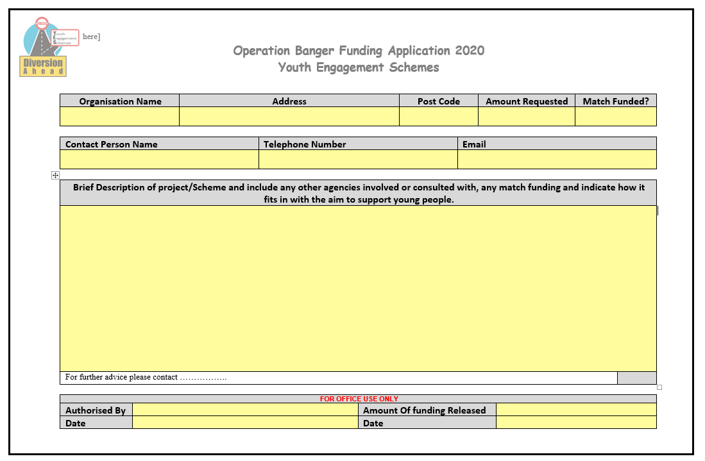

Please complete the form in full. In order for us to process payments as quickly as possible please take note of the following:

ORGANISATION NAME – this should be the name of your organisation, such as “Edge Lane Community Centre.” It should **not** be the name of your project or event

ADDRESS AND POSTCODE – please provide these as it helps our admin team make payments

CONTACT PERSON – please provide a name, telephone number and email of someone who we can contact. Occasionally forms are submitted to us with incomplete details and we have to make contact in order to progress payments. In order for us to make the payments as quickly as possible please provide details of someone who will be available.

BRIEF DESCRIPTION OF PROJECT – Please provide a brief description of the project or activities you will be undertaking. Strong grant applications often include

* Detail where and how the money will be spent
* Detail the time frames of the activities and how these will link in with the peak times of anti-social behaviour associated with the Halloween and bonfire night period.
* Detail the age and number of young people you intend to divert – again so we can assess the impact you anticipate you will have in helping your local community.

You will also receive a second document, the Supplier Form:

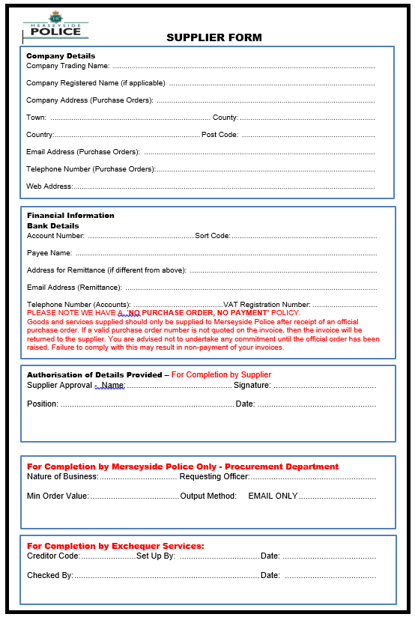

Please complete the top 3 boxes fully as we need these details for payment.

You will also receive a 3rd document, Funding/Grant check form:

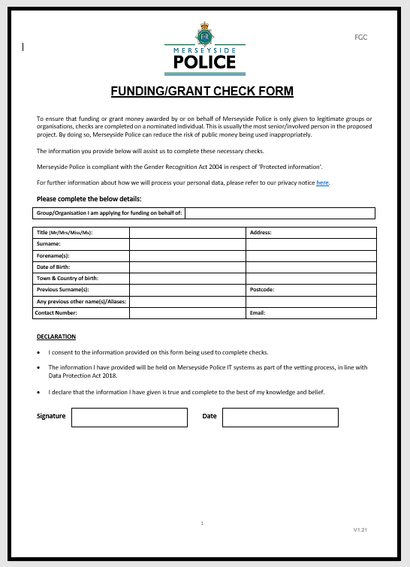

Please complete this in full and return it with your application. Please can the person specified on the form be someone connected to/manages your youth club or organisation.

Finally, can you provide an invoice for the amount you are requesting. Your invoice should include the following:

•a unique identification number

•your company name, address and contact information

•the company name and address of the customer you’re invoicing:

PCC for Merseyside

PO Box 59

Liverpool

L69 1JD

•a clear description of what you’re charging for

•the date the goods or service were provided (date of your diversionary activity)

•the date of the invoice

•the amount(s) being charged

•VAT amount if applicable

•the total amount owed

These documents are needed to ensure swift payment.

**Please return your completed Grant Claim Form, Supplier From, Funding Grant Check Form and Invoice to your local policing team.**

**The deadline for applications is 30/09/2022. Any applications submitted after this date will not be considered.**

Good Luck!