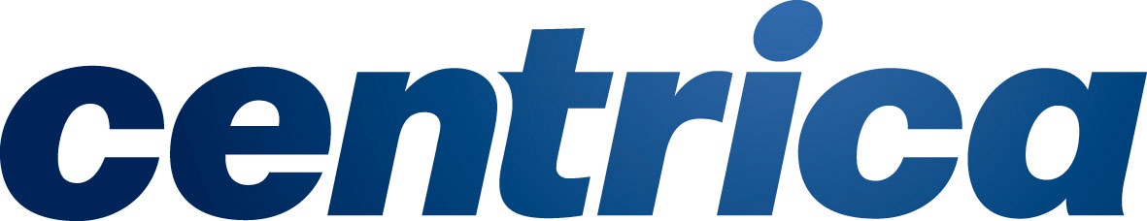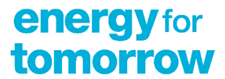

**Energy for Tomorrow Application Information**

## What are we looking for?

We’re seeking out projects, initiatives and ideas that can accelerate the energy transition. We want to hear from community groups or other registered organisations who are enabling a more inclusive and sustainable future for our communities.

We want to support those who have a clear social mission; a viable and feasible idea; and can demonstrate one or more of the following:

**You're energy innovators:** Developing sustainable and innovative solutions that reduce carbon emissions by empowering communities and transforming how they manage their energy - and help the UK reach net zero

**You're changing behaviours:** Engaging individuals to better understand their energy use, how they impact the environment and inspire them to do things differently for a more sustainable future

**You're supporting communities:** Encouraging collaboration within communities to deliver projects that have a far-reaching impact, ensuring no one is left behind

**Who we can support:**

We welcome applications from UK based charities, CICs, registered community groups, not-for-profit and for-profit companies that can demonstrate both a positive environmental and social impact. There will also need to be a financially sustainable project plan once the funding has come to an end.

**We cannot support:**

* Individuals or Local Authorities (although we can support a partner working with a Local Authority)
* Requests to support staffing and/or management costs only (unless related to Energy Efficiency/Debt Advisers)
* Requests to support marketing costs only
* Requests for funding to re-pay loans
* Feasibility projects (unless this is a small part of the application or part of a pilot scheme that can then be scaled)
* Proof of concept projects (unless it’s a pilot scheme in community)



**Energy for Tomorrow Application Form**

*Please complete this short application form to help us better understand your initiative and how we can support you.* For each section, *please use a maximum of 250 words per section.*

*Once completed please send to Sarah Wright* ***at eft@centrica.com***

|  |  |
| --- | --- |
| **Company/Project Name** |  |
| **Company/Charity No.** |  |
| **Where did you hear about Energy for Tomorrow?** |  |

|  |
| --- |
| **Project Overview (250 words):**  *[Please give a summary of the project/initiative]* |
| **Amount of grant required and timeframe (250 words):**  *[Typically, our grants range from £10,000 to £100,000 over a period of up to 3 years]* |
| **Background to social/environmental issue (250 words):**  *[Tell us about the social/environmental issue that you aim to address and include any relevant data points]* |
| **Strategic plan for grant funding (250 words):**  *[What are the aims and objectives of the activity planned and how does this link with the above social/environmental issues?]* |
| **Intended social impact (250 words):**  *[Measuring social impact is very important to us. What impact will your initiative have, what data will you collect and how will you report on it?]* |
| **Your Team (250 words):**  *[Who are the other members of your team and what are their roles?]* |
| **Other partners (250 words):**  *[If the grant request doesn’t cover the total cost of the project please give details of other funding partners.​]* |
| **Support from Centrica (250 words):**  *[What other in-kind support such as volunteering, pro bono financial, planning, strategic advice would you benefit from?]* |