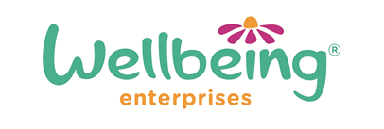

Equality and Diversity Monitoring Form

In accordance with our Equality and Diversity Policy and/or project specifications, we are monitoring to ensure that Wellbeing Enterprises CIC provides equal opportunities for access to courses or employment and to make sure that discrimination does not occur because of race, sex, sexual orientation, gender reassignment, religion of belief, marital or civil partnership status, age, disability or pregnancy or maternity.

All information supplied will be treated in confidence and will be stored either on paper records or a computer system in accordance with the Data Protection Act 1998 to be used only to monitor the diversity of Wellbeing Enterprises activities.

1. Gender | Male  Female
2. Marital Status | Married  Divorced | Single  Widowed |  | Separated  Other:
3. Ethnic Origin | White British  Black/Black British  Chinese | White Irish  Asian  Mixed |  | White Other  Asian British  Other:
4. Disability | Do you consider yourself to be disabled under the Equality Act 2010?  (The Disability Discrimination Act (1995) – still in force under the Equality Act 2010 - defines disability as “a physical or mental impairment that has a substantial, long-term and adverse effect on a person’s ability to carry out day to day activities.) |  |  |  | Yes  No
 | If yes, what is the nature of your disability? (optional)
5. Age Range | 16 - 24  45 - 54 | 25 - 34  55 - 64 |  | 35 - 44  65+

