Mountain Biking

Cycle of Life can provide a 3-hour mountain bike ride from KIMC. Participants will learn/develop:

* How to prepare themselves and their equipment for a journey.
* A group of people with bicycles in front of a building

  Description automatically generated with medium confidenceHow to set off and stop safely on the road.
* How to evaluate risks and communicate effectively with other road users.
* Where and when to position themselves on the road.
* How to negotiate junctions with other road users.
* How to use weight to maintain balance when riding off-road.
* How to use gears effectively on and off-road.
* How to use breaks effectively on and off road.

These skills are essential when commuting or social rides with friends and family! They are also useful skills when it comes to experiencing/entering other disciplines of cycling such as cyclocross or sportive.

The course will run from KIMC, all helmets and bikes can be provided but you’re welcome to bring your own. This is suitable for all levels so if you’re not very confident please don’t worry!

Liverpool Landmark Tour

Your group will be led around Liverpool’s most famous landmarks! Great for people who are looking to get more involved in cycling but aren’t so confident, those looking to get back into cycling, or those who want to learn a little more about cycling and see more of the city! Participants will learn:

* How to prepare themselves and their equipment for a journey.
* 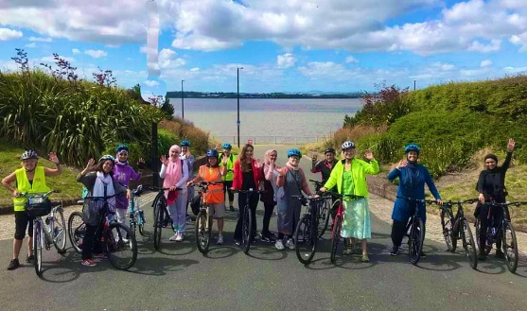How to set off and stop safely on the road.
* How to evaluate risks and communicate effectively with other road users.
* Where and when to position themselves on the road.
* How to negotiate junctions with other road users.
* How to negotiate complex junctions alone and as a group.
* How and when to use cycling infrastructure.

All helmets and bikes can be provided, and the course will begin and end at KIMC. Duration is approximately 3 hours.

Park Ride

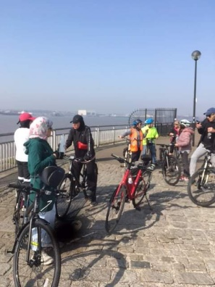Cycle of Life can lead a group around several of the beautiful parks Liverpool and the Wirral have to offer. The 3-hour ride will take participants on the road around Liverpool and the skills to cycle on the road safely and confidently with other road users will be taught along the way! Participants will learn:

* How to prepare themselves and their equipment for a journey.
* How to set off and stop safely on the road.
* How to evaluate risks and communicate effectively with other road users.
* Where and when to position themselves on the road.
* How to negotiate junctions with other road users.
* How to use cycling infrastructure.

Bikes and helmets can be provided, and sessions will run from KIMC. The course is for all abilities and fitness levels so please don’t worry about not being good enough or being too slow!