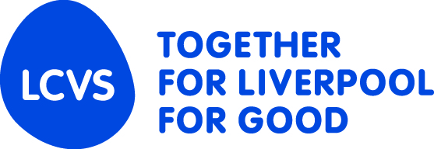
COMMUNITY
IMPACT
FUND

The Big Liverpool Get Together 2017

Earlier this year family and friends of Jo Cox, the MP who was tragically killed in 2016, organised the Great Get Together. Thousands of people took part across the country in a show of strength and solidarity.
When the Great Get Together took place, we were impressed by what we saw and thought it would be a good idea to try and replicate that here in Liverpool. With that in mind, we launched a special, one-off small grants round which is a little different from our normal Community Impact Fund.
We want to celebrate our great City by bringing people together for our own Big Liverpool Get Together. Jo’s family and friends explained it like this:
“A get together is any gathering of neighbours, friends and those in our communities to celebrate what we have in common. We hope it provides a reason to reach out to those you might not otherwise, and by building new relationships, create stronger communities.”

How does it work?
Eligible organisations can apply for grants of up to £1,000 for projects that bring people together over the next few months. Applications have to come from community led organisations and, as usual, you’ll need a constitution or set of rules, a bank account with at least two signatories and appropriate policies and insurance in place.

What you can apply for
We believe that strong communities are vital and that only by working together can we support those who are most vulnerable. We want to fund projects that bring together people within communities from different backgrounds, of different ages and with different outlooks, to increase mutual understanding and to help people work together to improve their community.
We’d like to see a wide range of events taking place, such as a street party, using a community centre to bring people together, activity days, picnics – whatever you can think of! We will support either one-off events or a series of events.
We will only fund activities that can show how people who perhaps don’t normally get together are going to be involved – we want people to reach out to other communities and to use their events to bring people together.

How much can I apply for?
The maximum amount an organisation can apply for is £1,000 but we expect most applications to be in the region of £500 - £750

Monitoring and Evaluation
We’ll want to know how your activity or event went, so we will be asking all successful applicants to take photos, get feedback from those taking part and to let us know of any specific links you’ve made that, perhaps, would not otherwise have happened.

Future Plans
We fully intend to run our normal Community Impact Fund for organisations later in the financial year. Please keep checking the LCVS website for information.

Exclusions
This funding is not for:
- Start-up costs for new organisations
- Organisational running costs
- Medical research
- Vehicles
- Schools or activity taking place in school time
- Sports kits or general fees (league fees etc.)
- Individuals
- The advancement of religion
- Animal welfare
- Other grant making bodies
- NHS Trusts
- Parent Teacher Associations
- Replacement funding (e.g. statutory funding coming to an end)
- Loans or business finance
- Universities
- Sponsorship/marketing appeals/fundraising costs
- Overseas projects/travel
- Safety equipment for individual households
- National charities
- CCTV installation

Please read the form and guidance notes carefully before completing your application. Incomplete applications cannot be accepted.
Send your application form as a WORD document via email to grants@lcvs.org.uk.

Other formats (PDF etc.) will not be accepted and LCVS cannot accept any responsibility for processing applications not in the correct format.
If we can be of any help, or you would like to talk to us about your project, call us on 0151 227 5177.

