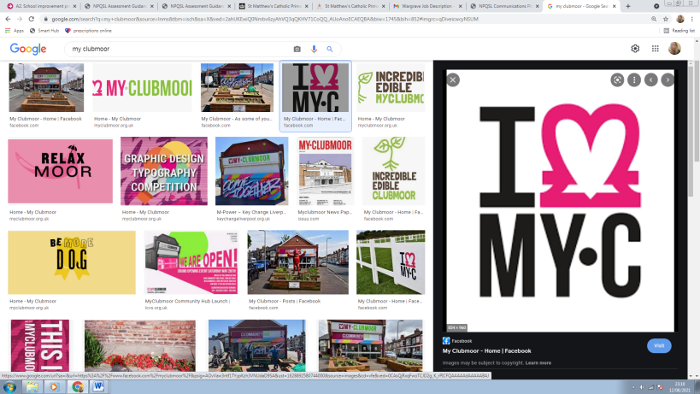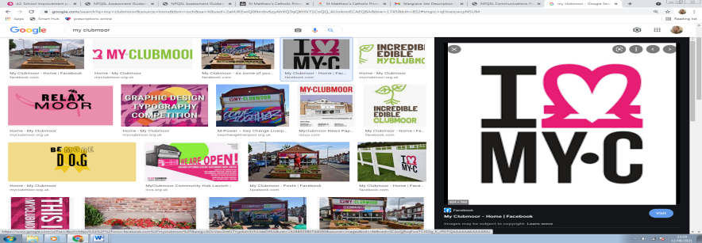**My Clubmoor Hub Manager and Administrator**

**Job Description**

**Role**: My Clubmoor Hub Manager and Administrator

**Responsible to:** LCVS Director of Finance and Resources and MyClubmoor Board Chair

**Responsible for:** N/A

**Location:** My Clubmoor Hub, 56 Maiden Lane, Clubmoor, Liverpool L13 9AW

**Salary:**  £23,000 per annum

**Working Hours**: 35 Hours per week

**Summary of the Role (Hub Manager)**

1. The Hub Manager and Administrator will be based predominantly at the My Clubmoor Community Hub with some hours undertaken at various locations within Clubmoor, Liverpool and the surrounding areas. This may vary depending upon relevant community outreach projects related to the Myclubmoor vision and Plan. This role will involve management of the general day to day running of My Clubmoor Hub. The role will involve maintaining the highest standards inside and outside the building, including maintenance and health and safety, to ensure that everyone, visitors, staff and volunteers, experiences a quality welcome at the My Clubmoor Hub.
2. Proactive, working well as part of a team, enthusiastic and passionate about making a difference to the local community and making My Clubmoor a thriving Hub.
3. Practical and administrative support for the Big Local Partnership alongside the operation of the Community Hub, including: opening and closing of the building for community workshops and events including weekends and evenings as necessary. The Administrator will work alongside the Big Local Partnership to ensure that the Hub is a: vibrant and community-orientated facility that operates for the benefit of local residents.

**Summary of the Role (Administrative)**

1. To carry out any necessary practical and administrative functions (including financial recording and reporting) which are necessary for My Clubmoor to function.
2. To contribute to the development of the Hub, providing ideas and support to the My Clubmoor Big Local Partnership especially in relation to the on-going viability of the Hub in light of our 2021 consultation with local residents.

**Administrative Key Responsibilities**

**Procedural**

1. To work with efficiency and effectiveness both independently and as part of the team at My Clubmoor
2. To have a positive attitude when working with the community, volunteers and members of the board.
3. To be responsible for administrative systems and processes including supporting the staff team with reports, publicity materials and databases.
4. To be responsible for a range of essential administrative tasks such as filing, photocopying and data inputting.
5. To provide administrative support to the Board as required, including liaising with the Chair in preparation of agendas and circulation of papers, attendance at board meetings and taking of minutes.
6. Support the Partnership in developing and reviewing the My Clubmoor Big Local Plan and work closely with the Partnership to assist the development of its projects and ideas.
7. To provide excellent customer service when welcoming visitors to the Hub and when answering enquiries.
8. Willingness to discuss any issues that may arise between any of the stakeholders at MyClubmoor.
9. Ensure that the Partnership’s Health and Safety, Safeguarding, Data Protection, Equal Opportunities and Environmental policies (and any future policies agreed by the Partnership), are implemented, and regularly reviewed.
10. Help plan and coordinate meetings and events and to risk assess events to minimise risks to volunteers, partners, and attendees
11. Provide advice and support to the Chair and members of the board.
12. Meet regularly with the Partnership Chair and LTO representative to review/agree new goals and targets as part of a personal development plan.
13. Keep up-to-date with Big Local and Local Trust policies and procedures, attending Local Trust learning events and other training specified by the Partnership.
14. To be aware of and adhere to all policies and procedures at all times.
15. Be flexible in the performance of duties and undertake any other duties as appropriate.

**Finance**

1. Liaise with the LTO to enable them to prepare up-to-date financial records, monitor the Partnership’s spending and produce spend reports for the Partnership and for Local Trust.
2. Take a value for money approach in acquiring goods and services and abiding by LCVS procurement policy at all times.

**Projects (including the Hub)**

1. Act as key point of contact for project leads and new project submissions, reviewing these as necessary with members of the My Clubmoor Board therefore maximising promotion to local residents, dealing effectively with enquiries.
2. Monitor projects and keep records as specified by the Partnership and LTO including producing quarterly reports and developing working relationships with existing and new service providers.
3. Help formulate the vision and plans that are submitted to The Local Trust at various points within the year.
4. Undertake the monitoring and evaluation of the Hub’s services and present these in an Annual Report

**Engagement**

1. Develop effective methods of engaging with residents to promote My Clubmoor Big Local and to encourage residents to participate in projects and access services including recruitment and retention of new Partnership members.
2. Help support the organisation and execution of community events
3. Be active in the My Clubmoor community and be committed to the promotion of My Clubmoor Big Local, supporting Partnership members with production of newsletters and keeping records and accounts (including photographic and filmic) of all Partnership activities.

**Community Hub Key Responsibilities**

**Building**

1. Ensure that arrangements are made for the opening and closing of the building, preparation of the Hub before and after lettings (to include setting up rooms as required by Hub users and the moving and putting away of equipment and furniture) and that the Hub is clean and secure
2. Deal with day to day building and maintenance issues, undertaking basic repairs and dealing with contractors when needed and as instructed by the My Clubmoor Big Local Partnership and/or LCVS.
3. Maintain and develop operational policies and procedures to ensure that the Hub is fully compliant with all legal requirements including Health and Safety, Fire and Buildings regulations, and that these are regularly reviewed

**Lettings**

1. Ensure appropriate support is given to all users of the Hub, to include an up to date User Induction Pack explaining the rights and responsibilities of individuals and organisations, and that key requirements are displayed.
2. Support the Partnership in developing positive relationships with users of the Hub, responding appropriately to queries, comments and concerns which may involve complex and challenging issues
3. Ensure that the Hiring Agreement set by the My Clubmoor Partnership is strictly adhered to.

**Administration**

1. Arrange room bookings in agreement with the Partnership, arrange payments / receipts, maintain an accurate lettings diary.
2. Order stationery and other consumables for the Hub as required and keep accurate financial records.
3. Develop effective and compliant IT systems for the Hub to store computer-based information.

**Staffing**

1. Attend relevant LCVS staff meetings and training when required for the role.
2. Assist the Partnership to recruit, retain and manage volunteers within the Hub in line with agreed policies and procedures.
3. Work closely and effective with new staff members.

**General**

1. Undertake any other tasks commensurate with the post as decided by My Clubmoor Big Local Partnership
2. To work as part of the team with other staff at Liverpool CVS.
3. To implement and follow LCVS policies and procedures.
4. To undertake any training necessary and participate in the organisation’s supervision and appraisal system, and identify further training and personal development needs.

**Equal Opportunities**

Liverpool CVS is committed to equal opportunities, anti-discrimination and anti-oppressive policy and practice. No one we have contact with may be discriminated against either directly or indirectly on the grounds of gender, race, nationality, religion, cultural group, marital status, sexual orientation, age, or impairment. The policies apply to job applicants, employees, volunteers and users of our services.

**Job Description**

### All jobs are subject to change from time to time and this job description will be reviewed regularly.

This job description is a guide to the work you will be required to undertake and represents a range of responsibilities commensurate with the grade for the post.

|  |  |
| --- | --- |
| Prepared by | My Clubmoor Board |
| Reviewed by | Graham Wright |
| Dated | August 2021 |

