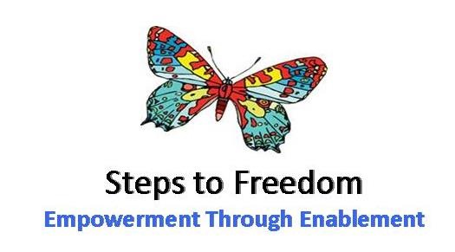

**Private and Confidential**

Please complete this form in block capitals and return to [jackie.moon@steps2freedom.org.uk](mailto:jackie.moon@steps2freedom.org.uk) or post to Steps to Freedom, Old School Site, Lister Drive, Tuebrook, L13 7HH.

**Personal Details**

Title: Mr, Mrs, Miss, Dr (please delete as appropriate)

First Name:________________________ Preferred Name:______________________

Surname:__________________________ Gender:______________________

Date of Birth:_______________________ Ethnicity (optional):____________________

Address:_______________________________________________________________________________________________________________________________________________________________________________________________________________________________________________

Telephone:_________________________ Email:_____________________________________

Are you a member of a professional counselling or psychotherapy body? Y / N

If yes, please state which body, your membership status and membership number:

__________________________________________________________________________________

Do you consider yourself to have a disability or any specific needs that you would like us to be aware of so that we can provide appropriate support? Y / N

If yes, please give details:_____________________________________________________________

__________________________________________________________________________________

Do you have any criminal convictions? Y / N

If yes, please give details on a separate sheet.

1

**Counselling Training**

Steps to Freedom expects that you are already qualified, please list all counselling training below, indicating any which you are currently undertaking. If necessary, please continue on a separate sheet.

|  |  |  |
| --- | --- | --- |
| **From – To** | **Place of Learning** | **Qualifications Obtained** |
|  |  |  |

**Counselling Experience**

How would you describe your theoretical approach?

__________________________________________________________________________________________________________________________________________________________________________________________________________________________________________________________________________________________________________________________________________________________________________________________________________________________________________________________________________________________________________________________________________________________________________________________________________________________________________________________________________________________________________________________________________________________________________________________________________________________________________________________________________________________________________________________________________________________________________________________________________________________________________________________________________________________________________

2

We’d like to know some more about the counselling work you have already done. Please tell us about your experience of working therapeutically with clients, including any details such as particular issues or specific client groups you may have worked with.

|  |  |  |
| --- | --- | --- |
| **From** | **Name of Organisation or Agency** | **Brief Outline of Work Undertaken** |
|  |  |  |

Please continue on a separate piece of paper if necessary.

What would you like to gain from working with Steps to Freedom?

____________________________________________________________________________________________________________________________________________________________________________________________________________________________________________________________________________________________________________________________________________________________________________________________________________________________________________________________________________________________________________________________________________________________________________________________________________________________________________________________________________________________________________________________________________________________________________________________________________________________________________________________________________________________________________________________________________________________________________________________________________________________________________________________________________________________________________________________________________________________________________________________

3

Steps to Freedom expects you have experienced personal therapy. Please give brief details of your own experience of personal therapy and how it has helped you and your practice.

__________________________________________________________________________________________________________________________________________________________________________________________________________________________________________________________________________________________________________________________________________________________________________________________________________________________________________________________________________________________________________________________________________________________________________________________________________________________________________________________________________________________________________________________________________________________________

When are you available to start working for Steps to Freedom?

__________________________________________________________________________________

**Supervision**

Please reflect on your own experience of supervision and how it has informed your practice as a professional.

|  |
| --- |
|  |

4

**References**

Please provide details of two people who are able to give you a reference. One must be your current/former employer.

|  |  |
| --- | --- |
| **Name:** |  |
| **Address:** |  |
| **Email:** |  |

|  |  |
| --- | --- |
| **Name:** |  |
| **Address:** |  |
| **Email:** |  |

**Other Information**

Please use this space to add any further information you want us to have to support your application.

|  |
| --- |
|  |

Signed:……………………………………………………. Date:_____/____/_______

**Thank you for completing the application form. We will be in touch soon.**

Steps to freedom is a company limited by guarantee registered in England & Wales No: 5916698

Registered Charity No: 1123205

5