
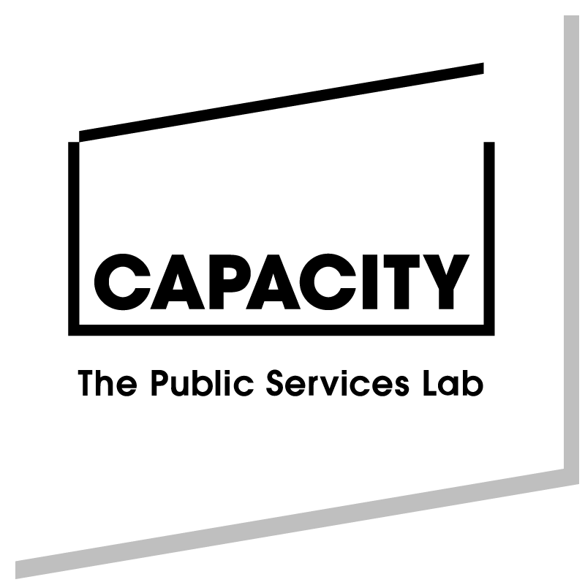

South Liverpool Community Connect Fund

Please complete all sections and please do not attach any additional sheets to this form. We may request additional information at assessment. Please note the word count.

section A: about your Organisation

Name of organisation:

Contact address:
Postcode:

Contact names and details:
 | Main Contact | Alt. Contact
Name:
Position:
Telephone:
Mobile:
Fax:
Email:

What are your organisation’s main or current activities?

Is your organisation:
A registered charity? |  | Charity Number:
Applying for charitable status?
A company limited by guarantee? |  | Company Number:
Other (e.g. social enterprise, playscheme, residents’ group, CIC):

When was your organisation established? | Year: |  | Month:

Are you part of, or affiliated to, a larger organisation? | YES / NO
(If yes, please give details, including head office address)

How many people are involved in your organisation?
Full time paid staff: |  |  | Part time paid staff:
Management Committee members: |  |  |  | Volunteers:

What was your organisation’s total income in the last three years?

2015/16 |  | Notes:
2016/17 |  | Notes:
2017/18 |  | Notes:

Bank account details: (This should be an account in the name of your organisation with at least two signatories.)
Name of Bank/Building Society:
Account Name:
Account Number:
Sort Code: |  |  | - |  |  | -

If you are successful in your application, to whom should the cheque be made payable? (NB This should be an organisation, not an individual. If you do not have a bank account for your organisation, please provide details of a community organisation that will accept the grant on your behalf.)
SECTION B: ABOUT YOUR APPLICATION

B1. Please describe how you will support the engagement of residents in South Liverpool with community activity across primary care settings (max 300 words)

When will the project take place? | Start Date: | End Date:

Please give an estimated number of beneficiaries for this project:

B2. Please tell us how you will engage with other local VCF organisations, and which organisations you will partner with (Max 250 words)

B3. Please tell us about the positive impact the project will have on the people taking part (Max 250 words)

B4. How will you monitor the progress of the project and evaluate its success? (Max 150 words)

SECTION C: FINANCIAL INFORMATION

C1. Have you ever received grant funding before from LCVS? | YES / NO

C2. How much are you requesting? | £

C3. Please give details of the costs for the project:
(please break down as appropriate e.g. hourly rates, hours per day/week etc)
 | £
 | £
 | £
 | £
 | £
 | £
 | £
 | £
 | £
 | £
 | £
 | £
 | £
TOTAL | £
Please attach suppliers' or providers' cost estimates or quotations if available.

DECLARATION

Before signing the declaration, please ensure you have completed all the sections in this application form, and that you have enclosed the documents requested on the checklist below where applicable. PLEASE NOTE YOUR APPLICATION CANNOT BE PROCESSED WITHOUT A SIGNED DECLARATION.

1. Please enclose the following documents with this application (tick boxes on the checklist):

The constitution / set of rules of your organisation

Your organisation’s latest annual accounts, or income/expenditure statement for the last 12 months

A copy of your organisation’s most recent bank

statement OR letter of confirmation from a community
group that will accept funds on your behalf

A copy of your organisation’s Safeguarding

Policy if your organisation works with children, young people or vulnerable adults

2. I am an authorised representative of the organisation. To my best knowledge, the information provided in this application form is correct.

Signature

Print name

Position in
organisation

Date

Please return this form as a WORD document via email
to grants@lcvs.org.uk
PLEASE NOTE: Forms sent in other formats may not be processed
Supporting documentation can be sent to:
Grants, LCVS, 151 Dale Street, Liverpool L2 2AH
CLOSING DATE FOR APPLICATIONS IS Monday 8th April at 5.00pm

