**LIVERPOOL’S EARLY HELP DIRECTORY**

**WORKFORCE DEVELOPMENT PORTAL**

**USER GUIDE**

**MAY 2017**

Open the directory via <http://ehd.liverpool.gov.uk>

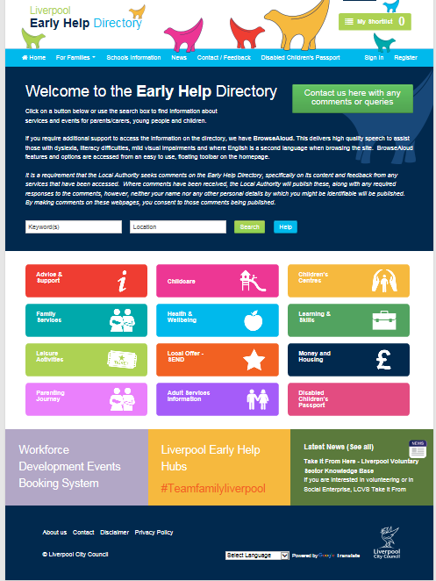

**You must register an account before accessing the booking system**. (If you have already registered, you do not need to register again). Click **Register** at the top right hand side of the home page.

Complete and submit the required information. You will now receive an email asking you to verify your details. Follow the instructions on the email.

Once registered you can **Sign In** from the home page.

You can manage your bookings from your account page in **My Bookings** section 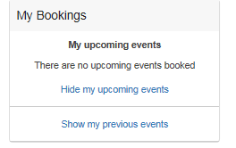

To view all Workforce Development sessions and Events, click into the portal



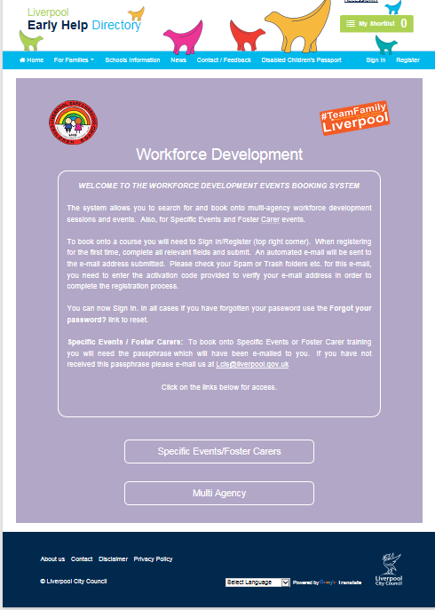

Click in the appropriate section i.e. Foster Carer or Multi Agency

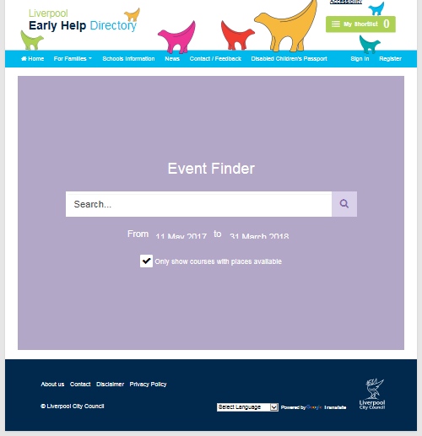

To search events, either enter a keyword in the search box, or to view all, simply click on the magnifying glass.

Simply follow the instructions on the page to book on your chosen session.

You will receive an automated email to confirm your booking.

If you have any queries, please contact [Judith.moizer@liverpool.gov.uk](mailto:Judith.moizer@liverpool.gov.uk)